### Part-I: Explainable AI with h2o Package

#### **Step 1: Setup Environment**

1. **Install h2o**: In your Python environment, install h2o. You can do this using pip:

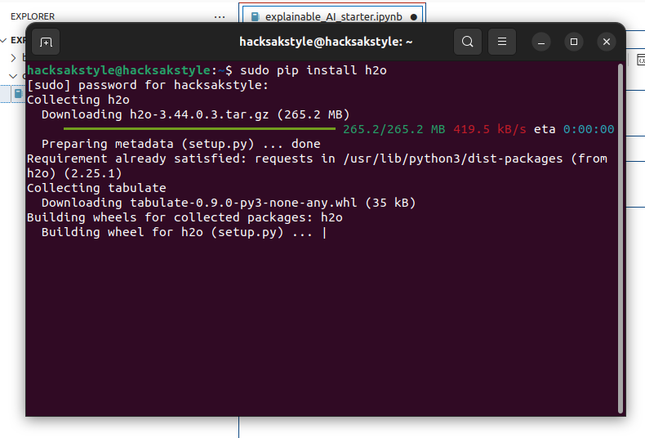

**2.Load Dataset**: Download the Bike Sharing Dataset from the UCI Machine Learning Repository and load it into Python.

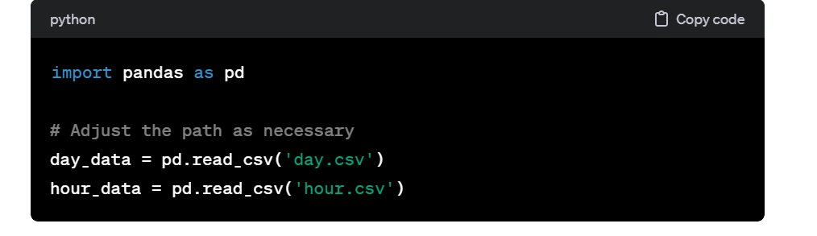

#### **Step 2: Data Preprocessing**

1. **Split Data**: You already have separate day and hour datasets.
2. **Preprocess**: Handle missing values, encode categorical variables, normalize data if needed.



#### **Step 3: Model Building**

1. **Initialize h2o**:

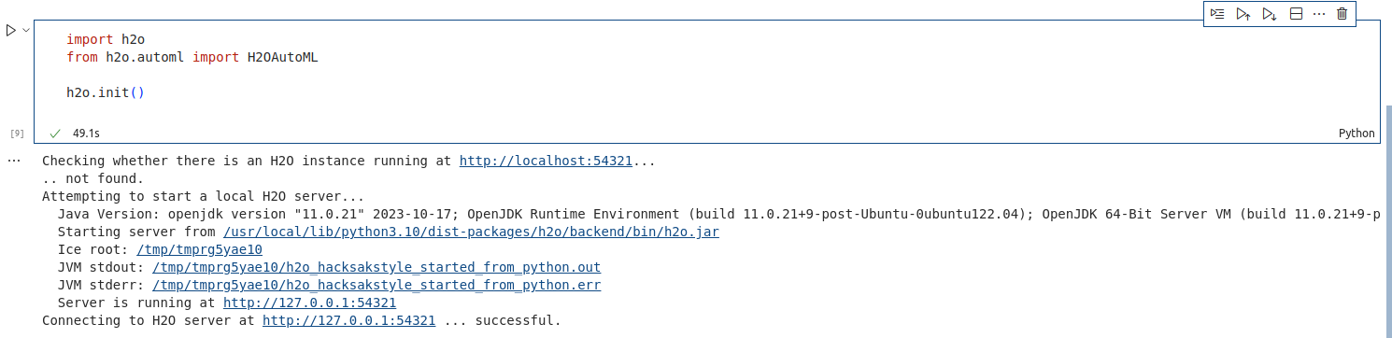

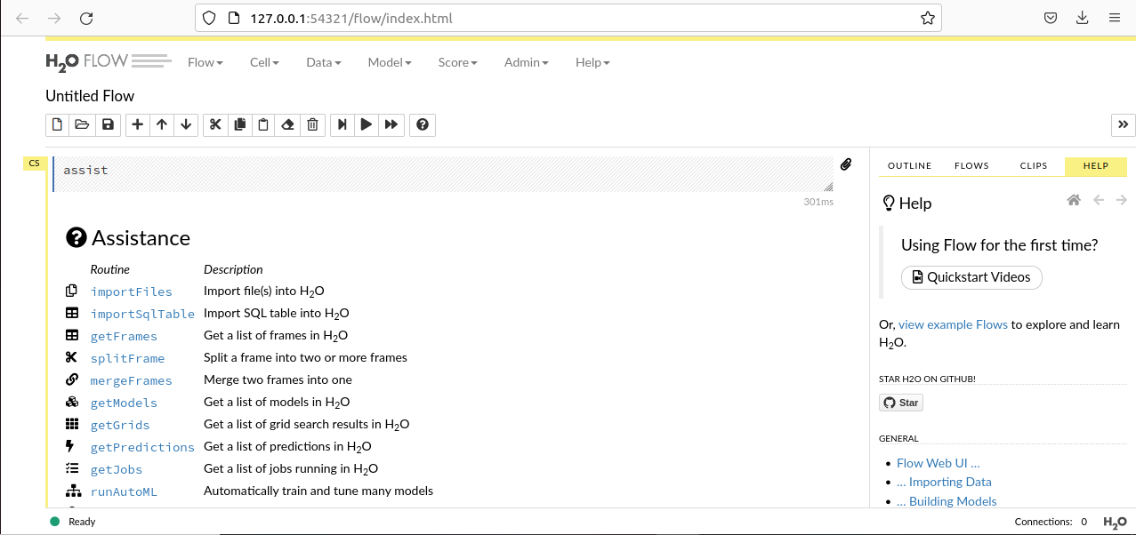

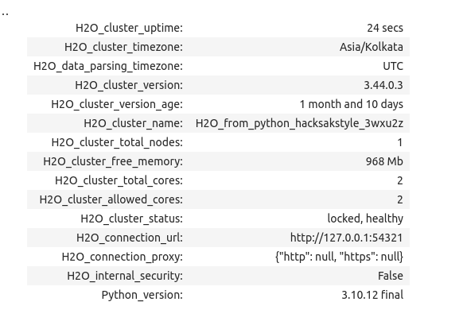

1. **Convert Pandas DataFrame to h2o Frame**:

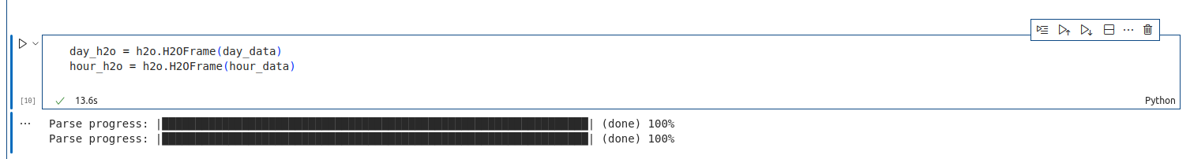

1. **Set Target and Features**:

1. **Model Training**:

* Train with AutoML:

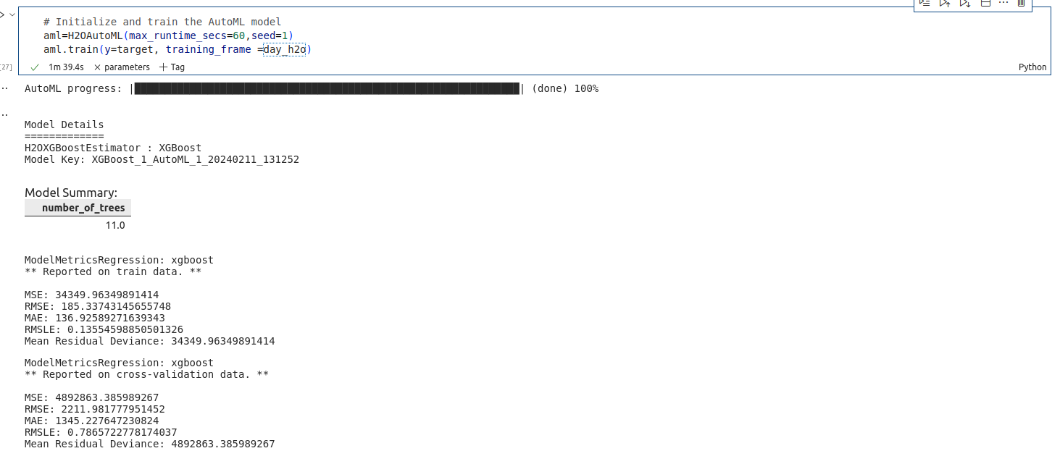

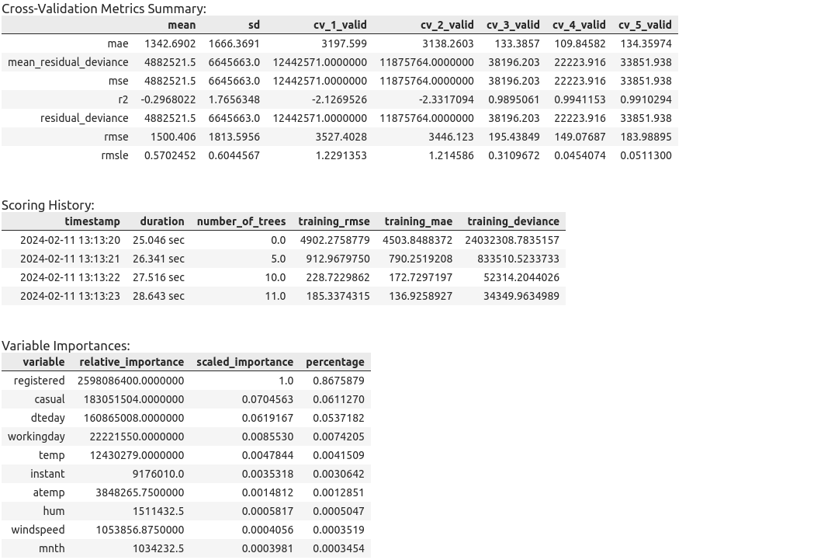

Train a Gradient Boosting model:

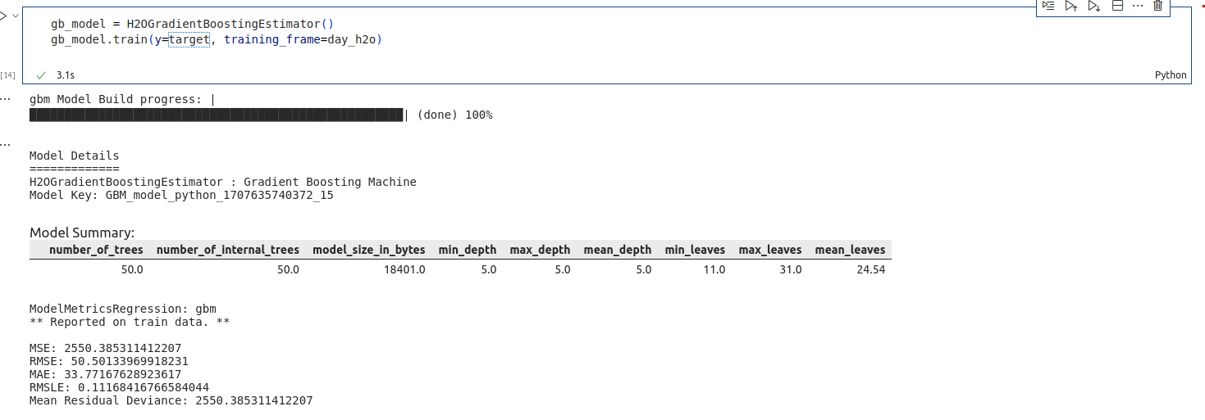

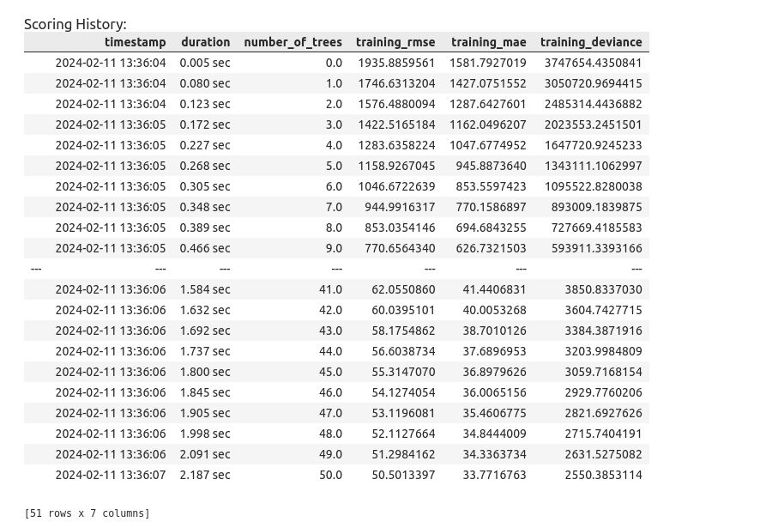

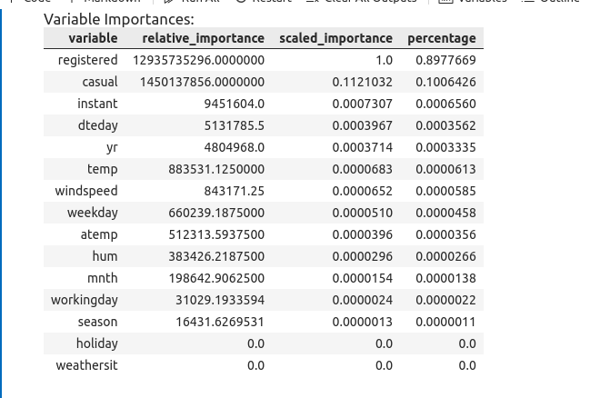

#### **Step 4: Explainability Analysis**

1. **Variable Importance Plot**:
   * Can be generated using h2o's plotting functions.
2. **Partial Dependence Plot**:
   * Helps in understanding the relationship between predictors and the response.
3. **Document Findings**: Write down how different features impact the model's predictions.

